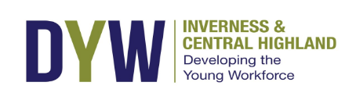
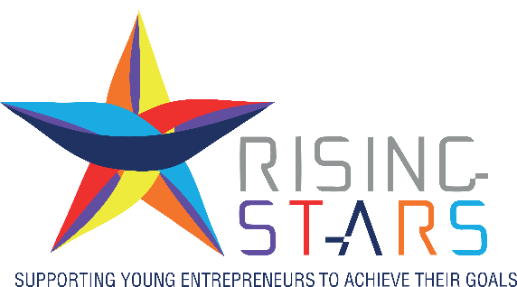


Rising Stars at Highland Spotlight – 22nd September 2026
Thank you for your interest in Rising Stars at Highland Spotlight
What is Highland Spotlight?
Highland Spotlight, the Highlands' biggest dedicated business to business exhibition returns on Tuesday 22 September, providing organisations and companies the time and space to meet together in a collaborative setting.
Part of Highland Business Week, which this year will run from Monday 21st to Friday 25th September, Highland Spotlight provides an opportunity to forge lasting connections with people across the region and learn more about the products and services available on our doorstep.
Businesses of all sizes and across all sectors are welcome to exhibit at Highland Spotlight, where we see around 300 people through the doors each year.
What are we offering
Following the success of our Rising Stars zone at Spotlight over the last two years, we are again this year offering up to 10 young entrepreneurs sponsored exhibition space, worth over £500 each, free of charge.
Every exhibition space package includes a covered table and chairs, access to power, and exhibitor listing in the exhibition show guide.
A place in the Rising Stars Zone will support you to:
- Connect with local businesses, including other young entrepreneurs, to grow your business
- Grow your professional network

- Exhibit free of charge (normal cost £440 +VAT) – fully sponsored place via Inverness Chamber of Commerce
- Raise your profile through Inverness Chamber driven Rising Stars pre-exhibition and post- exhibition media campaign
- Shape the future of Rising Stars and inspire the next generation of young entrepreneurs
Who can apply
Eligibility criteria:
- You must be under 35 years old
- Your business must be less than 3 years old
- You must be registered with HMRC (as a business or as a sole trader) and your business must be operational
- Must not have previously participated in the Rising Stars zone at Highland Spotlight

How to apply
Please complete application form below and return to Sandra at sandra@inverness-chamber.co.uk by Monday 17 August 2026.

You will be advised shortly after the closing date if you have been successful.

Rising Stars at Highland Spotlight Application Form 22nd September 2026
Please email completed application forms to sandra@inverness-chamber.co.uk by17th August 2026
Applicant name:
Age:
Business name:
Nature of business:
Date business registered:
Email address:
Phone Number:

The following questions can be answered in writing or by video. Each answer should be no more than 500 words, or 3 ½ minutes speaking. Please send videos in mp4 format via WeTransfer.

- Tell us about your business, what you have achieved so far and your goals for the next two years

- What would your business gain from exhibiting at Highland Spotlight?

