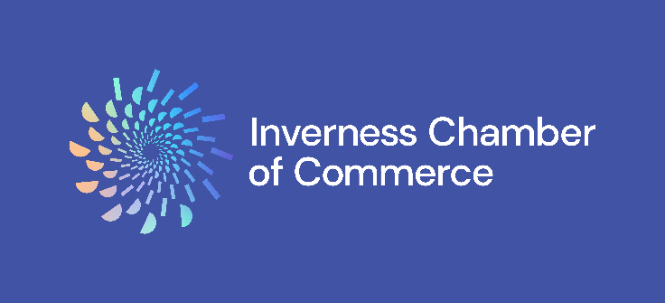

Inverness Chamber of Commerce - New Member Application Form

Business Name:

Trading As (if applicable):

Registered Company/Charity Number:

Address:

Telephone:

Billing Address (if different):

Business Email Address:

Email address of company representative (if different):

Finance/Billing Name and Contact Email:

Additional contact(s) (full name and email):

Where can customers find you online? (Please provide links)
Website:
Facebook:
LinkedIn:
Instagram:

Business Sector:

Number of Employees:

Business Description (This will help visitors to our website find and understand your business – please provide around 30 words):

Reason for joining the Chamber (one or two sentences):

If you were referred by another organisation, please let us know:

MEMBERSHIP FEES 2026
Membership fees are based on the packages outlined in our brochure and include a one-time £55 admin fee

Package | NET | VAT (at 20%) | TOTAL FEE | Tick as Appropriate
Digital | £345.00 | £69.00 | £414.00
Essential | £605.00 | £121.00 | £726.00
Growth | £1,035.00 | £207.00 | £1,242.00
Corporate | £1,535.00 | £307.00 | £1,842.00

Bespoke Partner packages available on request.

Membership is for a minimum 12-month term and will be automatically renewed on your renewal date unless prior notice is given to cancel. Please see our Full Terms and Conditions.

I wish to pay by (delete as appropriate): Invoice / Cheque / BACS / Direct Debit
(Our Finance Manager will be in touch)

Name: Position:

Signature: Date:

Our Contact Information:

Metropolitan House
31 – 33 High Street
Inverness
IV1 1HT

Tel: 01463 718131
Email: membership@inverness-chamber.co.uk
Web: www.inverness-chamber.co.uk




