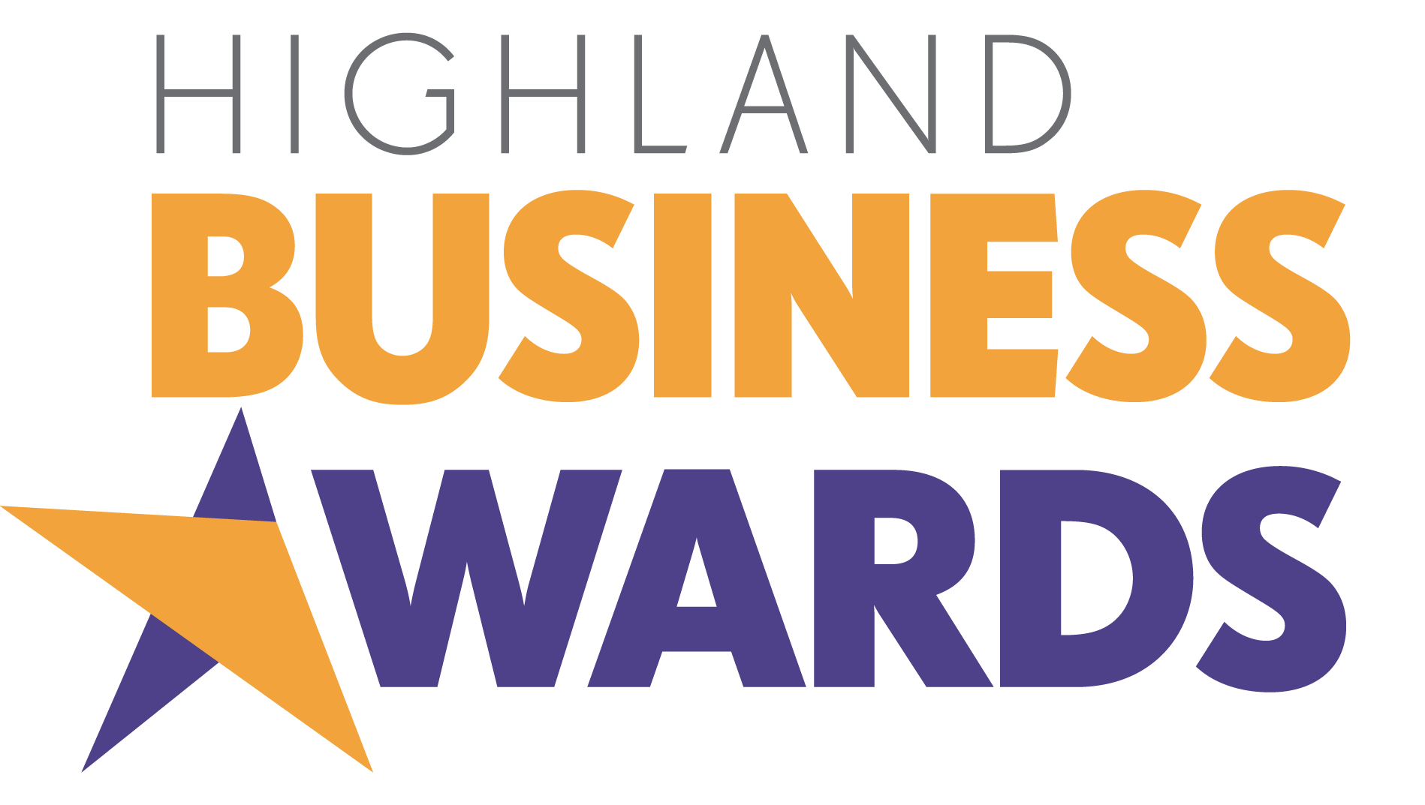

Friday 26 September 2025

Highland Business Award
for
Young Employee of the Year

A young person who makes a positive impact in the workplace thanks to their dedication, talent and can-do attitude.

Employers are invited to nominate a young member of their team up to the age of 24.

Sponsored by
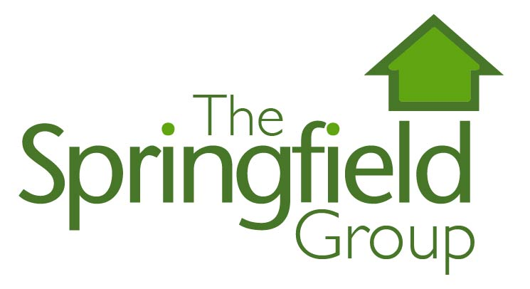

Section 1. Nominator and Nominee Details

Name of person making nomination:
Name of your organisation:
Your email:
Name of young person you are nominating:
Age of nominated individual:
Telephone of nominated individual:
Email of nominated individual:

Section 2. Nomination

Why do you believe the person you are nominating deserves to win the Highland Business Award for Young Employee of the Year?

Describe the qualities they demonstrate and the positive contribution they make to your organisation.

Your answer should be a maximum of 750 words and should be structured as follows:

- 400 words about the young person, their role, their attitude to the job and the qualities and skills they bring to your organisation
- 350 words on the impact and contribution they make to the business and to the rest of the team.

Please break your answer clearly into these two areas.

Awards Ceremony Voiceover Script

Please provide an 80 word summary that can be used as the basis for a voiceover script as part of the awards ceremony presentation, if your nominee is shortlisted. Focus closely on the areas outlined in the nomination, ie provide a very brief summary of what your nominated young employee does and centre mainly on their achievement in this award category. Please write this section in the third person, ie referring to the young employee and your organisation by name and using the pronouns he, she or they rather than we.

Authorisation
I have read and accept the rules and guidelines associated with these awards, and hereby enter this submission on the nominated individual’s behalf.

Name:
Date:

Please complete and save your nomination form electronically as nominee_category.docx, eg JoeBloggs_youngemployee.docx

Please submit your completed nomination form to events@inverness-chamber.co.uk along with 3 high resolution photographs and a png version of your organisation’s logo. These will be used if your nominee is shortlisted.

The closing date for nominations is Friday 8 August 2025. There will be no extension to this deadline.

The Highland Business Awards are part of Highland Business Week which is organised by
Inverness Chamber of Commerce and supported by Highland News & Media as media partner.
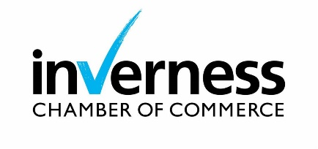


Nomination Rules

- Nominations are open to all businesses and individuals based in the Highlands & Islands and Moray irrespective of whether the nominated business or the business the nominated individual is affiliated with is a member of any of the region’s Chambers of Commerce. Businesses owned by parent companies or groups based outwith the Highlands & Islands or Moray may also be nominated provided the Highlands & Islands or Moray organisation can demonstrate a significant degree of autonomy over its operations, policies and strategies.

- Award sponsors, or businesses and individuals affiliated with award sponsors may not be nominated in the category they sponsor.

- Nominations are treated in confidence.

- All nominations must be electronic and completed on the Highland Business Awards nomination form only. No other format will be accepted.

- A maximum of 3 pieces of supporting information, eg press articles or photographs, may be included with the nomination form. Please avoid using web links within your nomination as these will not be activated by the judges.

- Nominations will be judged at two stages by an impartial panel of judges and a shortlist compiled. All those nominated will be informed by the organisers that they have been nominated.

- Award winners will be announced at the Highland Business Awards Lunch on 26 September 2025.

- Nomination to more than one category is permitted.

- The judges reserve the right to withdraw any category at their sole discretion, should the nominations for that category not meet the required criteria.

- Incomplete nominations will not be judged.

- All nominations will be acknowledged within 3 working days of receipt. Nomination forms will become the property of Inverness Chamber of Commerce and will not be returned.

- Proof of sending a nomination (by email) is not proof of receipt.

- The organisers reserve the right to withdraw an award from any nominee where false information has been supplied within the nomination. Judges reserve the right to verify any information supplied.

- The closing date for nominations is 5.00pm on Friday 8 August 2025. There will be no extension to this deadline.

- The judges’ decisions are final and no further correspondence will be entered into.

- Information supplied will be shared with the judging panel and, in the case of finalists, with the event host. It will be used only for the purpose of judging the competition and as the basis for creating a voiceover script and screen presentation for the awards ceremony, where required.

- Finalists may be included in related media coverage and may be required to take part in promotional activities about the Highland Business Awards.

- By completing a nomination for the Highland Business Awards you agree to these terms and conditions.

