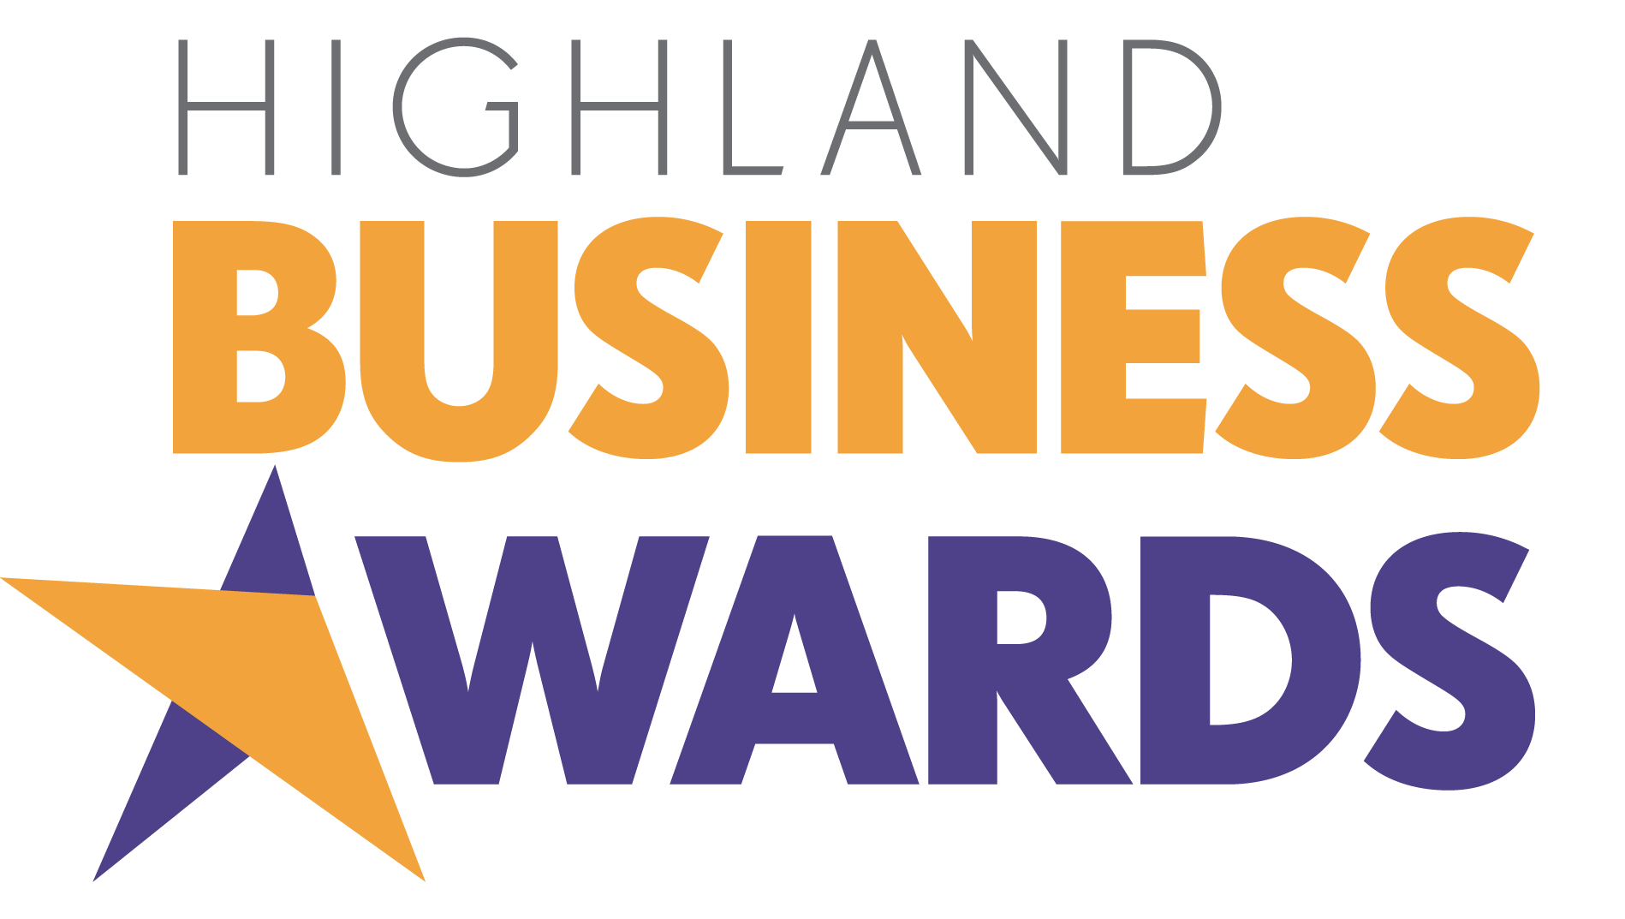

Friday 27 September 2024

Highland Business Award
for
Innovation

A business that has implemented new ideas, products or processes which have contributed to its success, whether in terms of profitability, new customers and/or new markets.

Organisations are invited to nominate themselves or they may nominate another business.

Section 1. Nominator and Nominee Details

Name of person making nomination:
Name of your organisation:
Your email:
Name of organisation you are nominating:
Name of organisation representative (if nominating an organisation other than your own):
Telephone of nominated organisation representative:
Email of nominated organisation representative (if different from above):

Section 2. Nomination

Why do you believe the organisation you are nominating deserves to win the Highland Business Award for Innovation?

Explain how the implementation of new ideas, products or processes have contributed to its success.

Your answer should be a maximum of 750 words and we would suggest approximately 150 words on the areas that needed an innovative solution, 400 words on the new ideas, products or processes and 200 words on the success this has led to, which could be demonstrated by an increase in profitability, customer numbers or engagement.

It would help the judges if you could break your answer clearly into these three areas.

Awards Ceremony Voiceover Script

Please provide a 100 word summary that can be used as the basis for a voiceover script as part of the awards ceremony presentation, if your nominated organisation is shortlisted. Focus closely on the areas outlined in the nomination, ie provide a very brief summary of what your nominated organisation does and centre mainly on their achievement in this award category. Please write this section in the third person.

Authorisation
I have read and accept the rules and guidelines associated with these awards, and hereby enter this submission on the nominated organisation’s behalf.

Name:
Designation:
Date:

Please complete and save your nomination form electronically as nominated organisation_category.docx, eg Bloggs&Co_innovation.docx

Please submit your completed nomination form to events@inverness-chamber.co.uk

The closing date for nominations is Friday 9 August 2024. There will be no extension to this deadline.

The Highland Business Awards are part of Highland Business Week which is organised by Inverness Chamber of Commerce and supported by Highland News & Media as media partner.


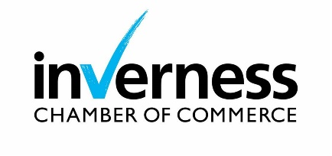

Nomination Rules

- Nominations are open to all businesses and individuals based in the Highlands & Islands and Moray irrespective of whether the nominated business or the business the nominated individual is affiliated with is a member of any of the region’s Chambers of Commerce. Businesses owned by parent companies or groups based outwith the Highlands & Islands or Moray may also be nominated provided the Highlands & Islands or Moray organisation can demonstrate a significant degree of autonomy over its operations, policies and strategies.

- Award sponsors, or businesses and individuals affiliated with award sponsors may not be nominated in the category they sponsor.

- Nominations are treated in confidence.

- All nominations must be electronic and completed on the Highland Business Awards nomination form only. No other format will be accepted.

- A maximum of 3 pieces of supporting information, eg press articles or photographs, may be included with the nomination form. Please avoid using web links within your nomination as these will not be activated by the judges.

- Nominations will be judged at two stages by an impartial panel of judges and a shortlist compiled. All those nominated will be informed by the organisers that they have been nominated.

- Award winners will be announced at the Highland Business Awards Lunch on 27 September 2024.

- Nomination to more than one category is permitted.

- The judges reserve the right to withdraw any category at their sole discretion, should the nominations for that category not meet the required criteria.

- Incomplete nominations will not be judged.

- All nominations will be acknowledged within 3 working days of receipt. Nomination forms will become the property of Inverness Chamber of Commerce and will not be returned.

- Proof of sending a nomination (by email) is not proof of receipt.

- The organisers reserve the right to withdraw an award from any nominee where false information has been supplied within the nomination. Judges reserve the right to verify any information supplied.

- The closing date for nominations is 5.00pm on Friday 9 August 2024. There will be no extension to this deadline.

- The judges’ decisions are final and no further correspondence will be entered into.

- Information supplied will be shared with the judging panel and, in the case of finalists, with the event host. It will be used only for the purpose of judging the competition and as the basis for creating a voiceover script for the awards ceremony, where required.

- Finalists may be included in related media coverage and may be required to take part in promotional activities about the Highland Business Awards.

- By completing a nomination for the Highland Business Awards you agree to these terms and conditions.

