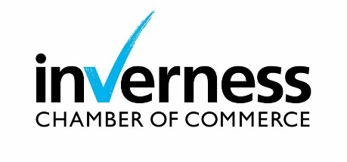

I wish to apply for my business to become a member of Inverness Chamber of Commerce.
I enclose our cheque / I have made a BACS payment / I have provided credit/debit card details/I have completed a Direct Debit mandate form (delete as appropriate and see overleaf for details) for the
appropriate membership fee. (minimum term 12 months).

I understand that my business will be regarded as a member from the time of application pending
formal approval by the Chamber’s Board of Directors.

I consent to the information below being held on the Inverness Chamber of Commerce database and website and being made available to other members through its membership directory.

Signed: Print name: Date:

Business Name …………………………………………………………………………………………………………………………………………………
Trading As (if applicable)…………………………………………………………………………………………………………………………………

Address ……………………………………………………………………………………………………………………………………………………………………………………………………………………………………………………………………………………………………………………………………………………
Postcode ……………………………………………………………
Telephone ............................................................
Number of employees .........................................

Business Email Address.........................................................................................................................................
Email address of company representative (if different) …………………………………………………………………………………………………………………………………………………………………………
Additional contact (s) (name and email) …………………………………………………………………………………………………………………………………………………………………………

Where can customers find you online?
Website .........................................................................................................................
Facebook .......................................................................................................................
X (Twitter) ......................................................................................................................
LinkedIn ......................................................................................................................
Instagram …………………….................................................................................................
Business Sector …………………………………………..........................................................................................................
Business Classification (s)(Please provide key terms for services that you provide to help us further categorise your business eg. A hotel could be classified as holiday accommodation, Bar/Restaurant, event venue, etc)

1. .......................................................................................................................
2. .......................................................................................................................
3. .......................................................................................................................
Business Description (This will help visitors to our website find and understand your business – please provide around 30 words)
................................................................................................................................................................................................................................................................................................................................................................................................................................................................................................................................................................................................................................................................................................................................................................................................................................................................................................................................................................................................................................................................................................................................................................................................................................................................................

Reason for joining Chamber ……………………………………………………………………………………………………………………………………………………………………………………………………………………………………………………………………………………………………………………………………………………………………………………………………………………………………………………………………………………………………………………………………………………………………………………………………………………………………………………………………………………………………………………………………………………………….

If you were referred by another organization, please let us know!
Referral by:……………………………………………………… Company ……………………………………………………………………………….

MEMBERSHIP FEES 2023

Membership fees are based on choice-based packages outlined in our brochure, and include a £55 admin fee.

 | NET | VAT  (at 20%) | TOTAL FEE | Tick if paying  Total Fee (Card, Cheque or BACS) | Paying  Monthly | Tick if  paying Monthly.  (Direct Debit)
Resilience | £330.00 | £66.00 | £396.00 |  | £33.00 Per Month
Essential | £575.00 | £115.00 | £690.00 |  | £57.50 Per Month
Growth | £985.00 | £197.00 | £1182.00 |  | £98.50 Per Month
Corporate | £1455.00 | £291.00 | £1746.00 |  | £145.50 Per Month
Resilience Plus and Partner packages available on request

Membership will be automatically renewed on your renewal date unless notice is given to cancel membership. Please see our Full Terms and Conditions.
To pay total fee by credit or debit card, please complete this section:

Card type ...................................................................................................................................................................

Number .....................................................................................................................................................................
.
Security code ....................................................... Expiry date ................................................................................

Name on card ............................................................................................................................................................

Signature

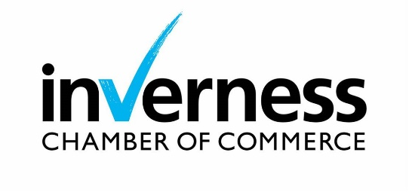
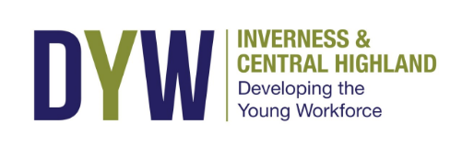
Inverness Chamber of Commerce
Metropolitan House
31-33 High Street
Inverness
IV1 1HT

Telephone: 01463 718131
Email: info@inverness-chamber.co.uk
Web: www.inverness-chamber.co.uk

Cheques should be made payable to
Inverness Chamber of Commerce.
BACS payments to:-
Account No: 16748407 Sort Code: 83-23-10
If you wish to pay by direct debit please return the
completed mandate with your application.
A VAT receipt will be issued on approval by the Chamber Board. VAT No: 682 8484 87

