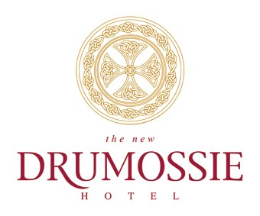
The perfect opportunity for the right candidate to take the next step in their events career, Drumossie Hotel are recruiting for an experienced Wedding & Events Co-ordinator for our client, a 4 star hotel located in Inverness due to increased business/demand.
The 44-bedroom hotel set in 9 acres of parkland hosts meetings, conferences, and events for up to 500 people. With the choice of 4 conference rooms, restaurant and lounge.
The Candidate:
You will have a demonstrable weddings and events background and a passion for delivering service excellence from the initial query though to the event.
The ideal candidate will be driven by excellent standards and looking to gain accolades with the venue and the brand and be joining a successful and engaged team. The role offers annual loyalty bonus and discretionary staff incentives which will be discussed at interview stage.
Competencies
- Great communications skills
- Excellent organisation skills
- Sales revenue management experience
- Event management experience
- External stakeholder engagement
- Business development/account management experience
Qualities:
- Flexibility – this role is 5 days/week over 7 days and will include some weekend working
- Enthusiasm
- Solutions focused
- Professional
- Efficient
Competitive remuneration package and the chance to join a successful, engaged team with excellent career development opportunities. If you would like to know more about this exciting opportunity please apply directly to gm@drumossiehotel.co.uk

